Capturing Business Automation Workflow events for external consumption
* Events are requests or responses sent from one component to another. You can process events in a specific sequence.
* When events fail, you can use the failed event manager to view, discard, modify, or resubmit the events.
* You can also use the Store and forward feature to prevent subsequent failures from occurring when a component calls asynchronously to a service that is unavailable.
* You can use the Event Manager monitor that is included in the Process Admin Console to troubleshoot processes that are supposed to run automatically (for example through an undercover agent) but fail to start.

*You can use the Event Manager monitor to identify underlying problems as well as controlling various aspects of Event Manager processing.

* The Event Manager is the component of the Workflow Server that handles event scheduling and queuing. For example, when an event is received by Workflow Server, that event is translated to a job in the Event Manager.

* Each job in the Event Manager is routed through a Scheduler, which schedules and tracks the execution of its assigned jobs.

* IBM Business Automation Workflow emits events that are typically monitored by Business Monitor. If you are not using Business Monitor but still need to collect events, perhaps for auditing reasons, you can configure the Dynamic Event Framework (DEF) and subscribe to events that you want to receive.

Dynamic Event Framework (DEF) :
* The Dynamic Event Framework is a mechanism for emitting and delivering events about significant system or business occurrences, as defined in a monitor model.
* This dynamic event handling can only be used for events from Business Monitor V8.5.5 and later or IBM BPM V8.5.5 and later. For earlier versions or other event sources, you must configure the event source to send events using the methods previously available.
The Dynamic Event Framework is responsible for the following functions:
- Configuration associated with defining an event source
- Registration, which tells an event source which events a monitor model expects to receive
- Sending events to consumers
Befor you go into the task make some changes in the was console
Login to WAS console : http://<hostname>:<port>/admin
Goto to the Path as follows :
1.Click Servers > Clusters > WebSphere application server clusters > cluster name > Business Process Choreographer > Business Flow Manager.
2. Make sure that Enable Common Event Infrastructure logging is selected.
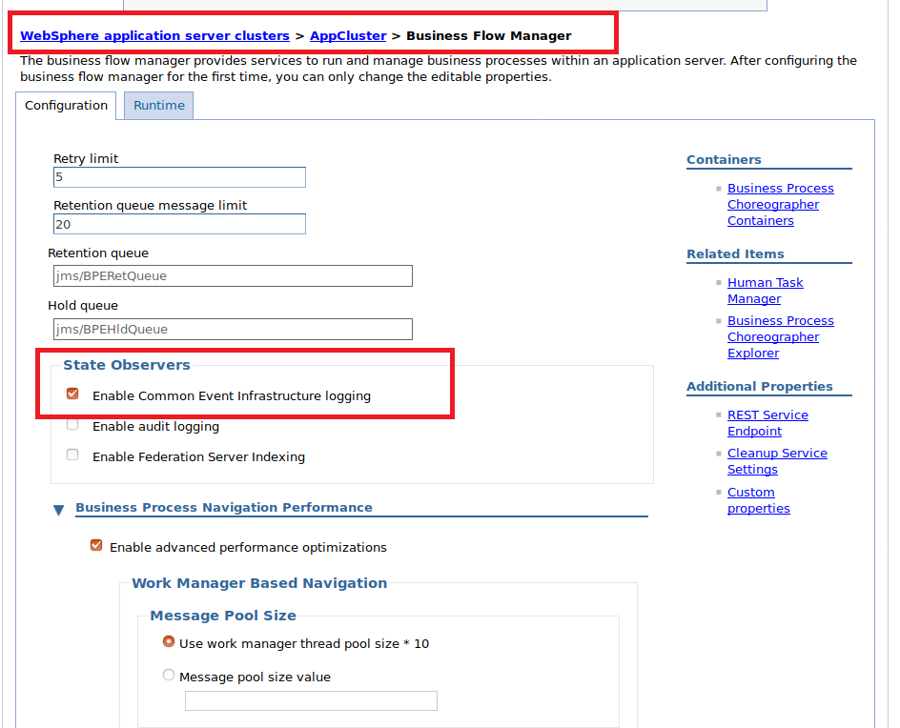

3.Click Servers > Clusters > WebSphere application server clusters > cluster name > Business Process Choreographer > Human Task Manager.
4. Make sure that Enable Common Event Infrastructure logging is selected.
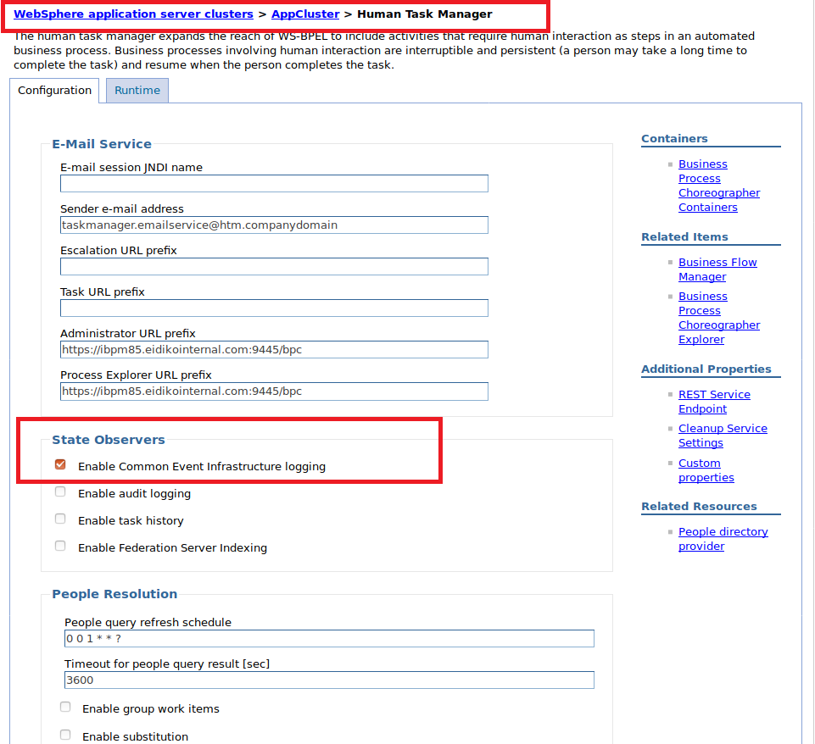

5.If you made some updates, save the configuration and restart the cluster.
Note: In Our Case i.e in Three Tier Cluster Select AppCluster if not select the cluster.

Steps to Capture IBM Business Automation Work Flow Events

Step 1: Create the following in IBM WAS Console

1.Define a destination on the Business Automation Workflow deployment environment bus.
Create a New BUS in Service Integation Section.
a.Click Service integration > Buses and click the bus. Click Destinations and add a new queue destination.
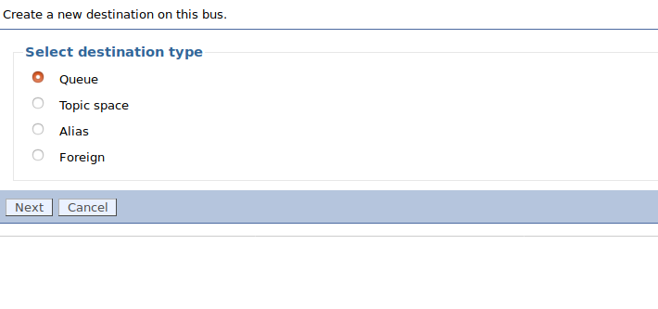

Make sure that the destinations will be of Queue type.

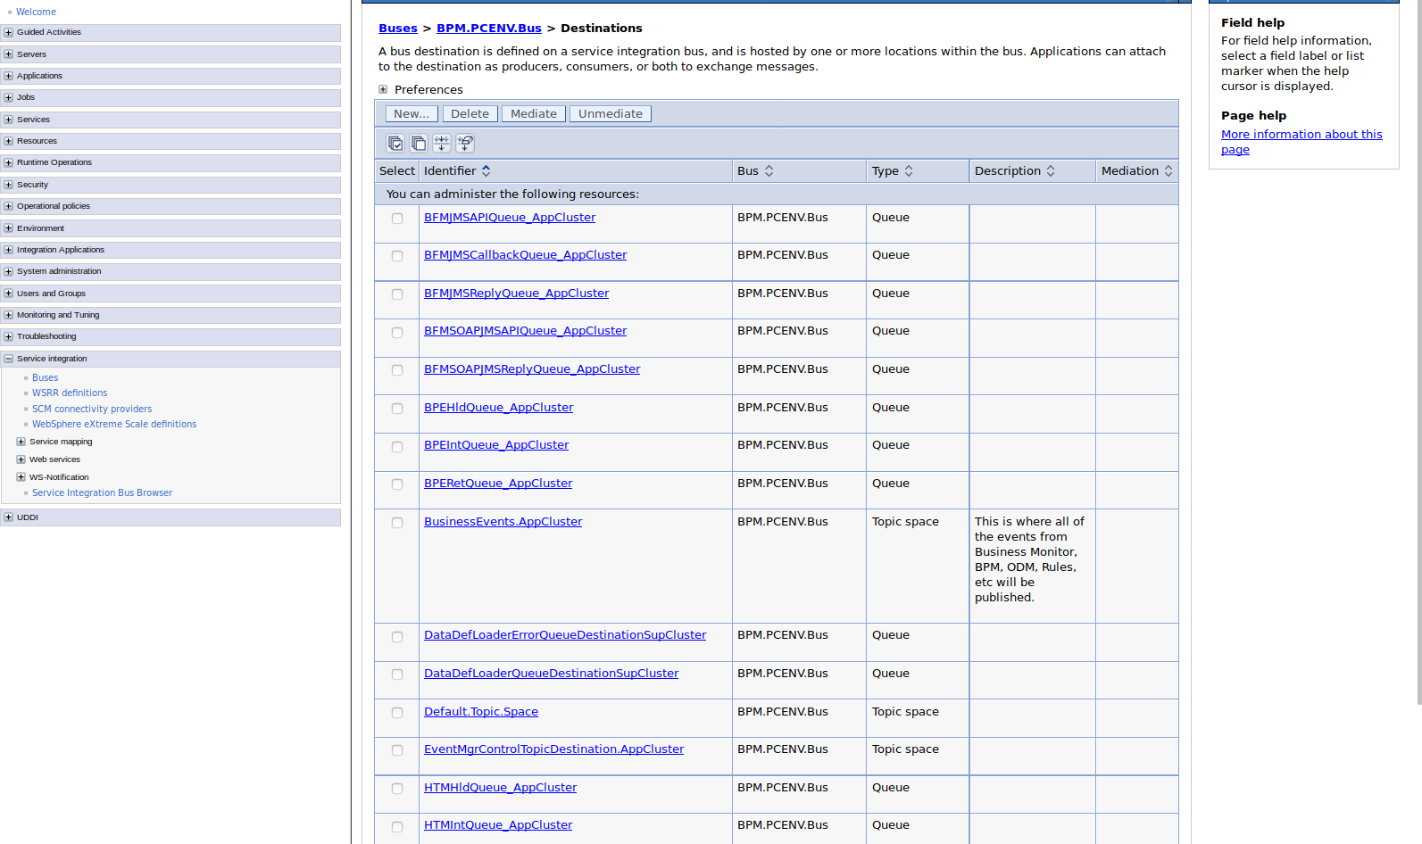

b.Create a JMS queue connection factory at the cell scope level.
click Resources > JMS > Queue connection factories.
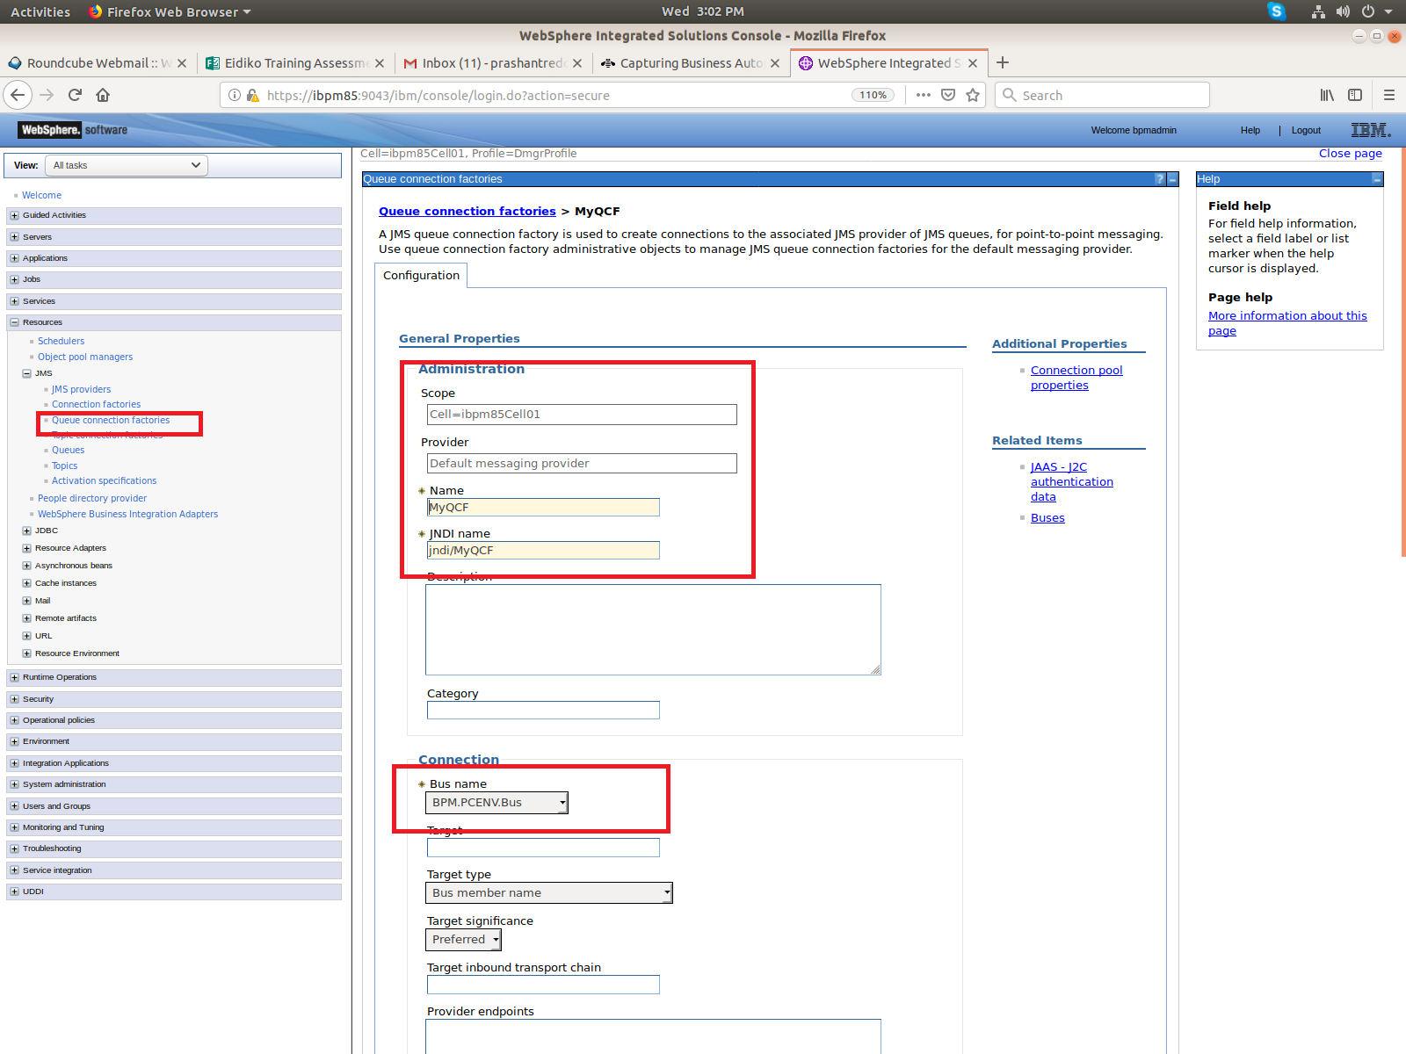
c.Create a JMS queue at the cell scope level. Click Resources > JMS > Queues.
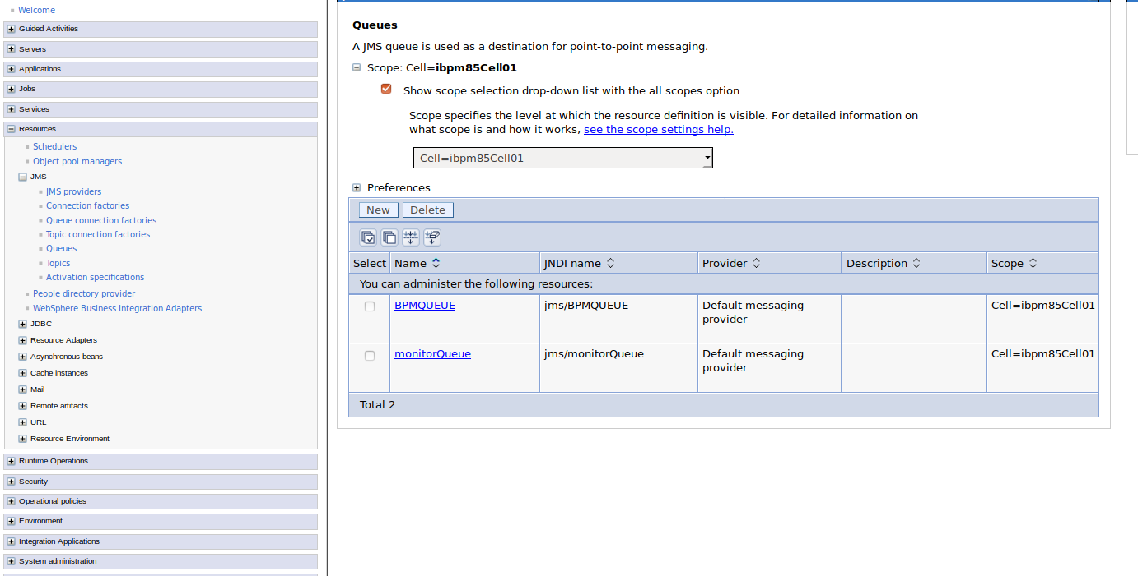
2. Update the SampleConfigureEventsToJMS.py script
Goto Server Location and to the path: /opt/IBM/WebSphere/AppServer/BPM/Lombardi/tools/def
You can see two files
i.SampleConfigureEventsToJMS.py ii.SampleReloadDEF.py

1.Edit the SampleConfigureEventsToJMS file and give the following values

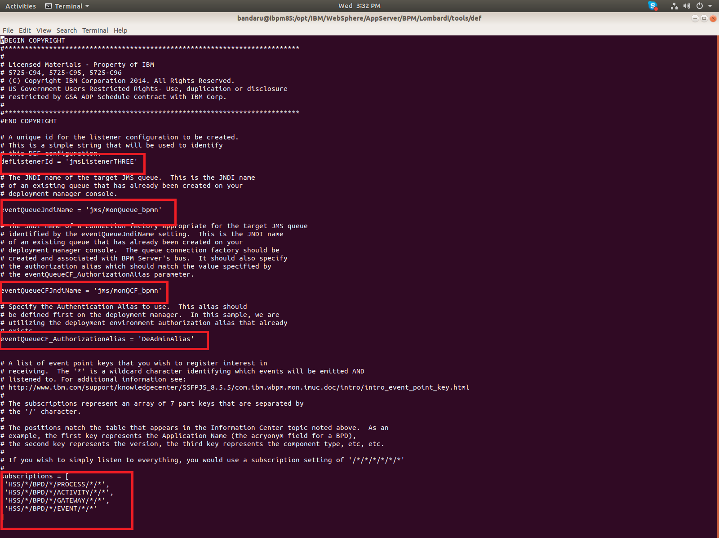
a.defListenterId A string value that uniquely identifies this listener.
b.eventQueueJndiName A string value that refers to the JNDI name of the queue resource created in WebSphere (eg:jms/MyQueue)
c.eventQueueCFJndiName A string value that refers to the JNDI name of the queue connection factory resource created in WebSphere. (Eg:jms/MyQCF)
d.eventQueueCF_AuthorizationAlias A string value that refers to the authorization alias created in WebSphere .In our case it is CellAdminAlias.

2.Specify the subscription array.
Each subscription in the subscriptions array is a single string with a '/' separator for each of the seven part keys. A comma is used to separate each subscription. The seven part keys are:
Application Name / Version / ComponentType / Component Name / Element Type /
Element Name / Nature
For more Description about Subscription follow the link
https://www.ibm.com/support/knowledgecenter/en/SS7NQD_8.5.7/com.ibm.wbpm.mon.imuc.doc/intro/intro_event_point_key.html

* To listen for every event for all applications, use the wildcard character as shown in the following example:
subscriptions=[
'*/*/*/*/*/*/*'
]
*The following example shows how you might register to receive events for the Hiring Sample:
subscriptions=[
'HSS/*/BPD/*/PROCESS/*/*',
'HSS/*/BPD/*/ACTIVITY/*/*',
'HSS/*/BPD/*/GATEWAY/*/*']
3.Run the script to configure DEF.
Goto path : opt/IBM/WebSphere/AppServer/profiles/DmgrProfile/bin

- At a command line, go to the bin directory under your deployment manager profile home directory. Run the SampleConfigureEventsToJMS.py script.
./wsadmin –lang jython –f c:\SampleConfigureEventsToJMS.py

- Run the SampleReloadDEF.py script to cause the DEF to refresh dynamically.
./wsadmin –lang jython –f c:\SampleReloadDEF.py

After you run the sample script, a defconfig.xml file is created in the dmgr_profile_home/config/cells/cellName directory.
opt/IBM/WebSphere/AppServer/profiles/DmgrProfile/config/cells/ibpm85cell/
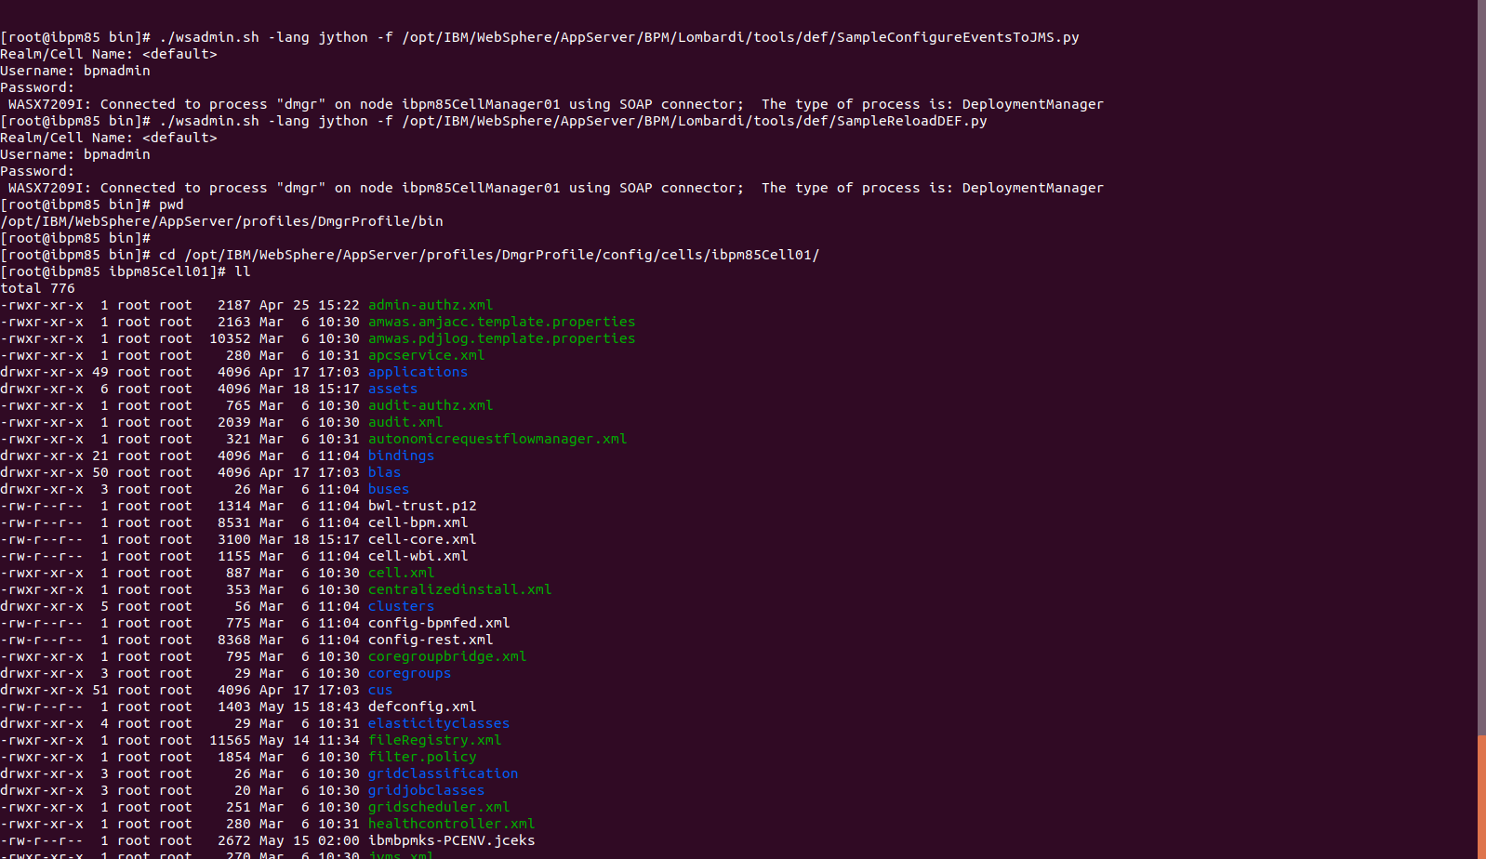

The defconfig.xml file looks as follows
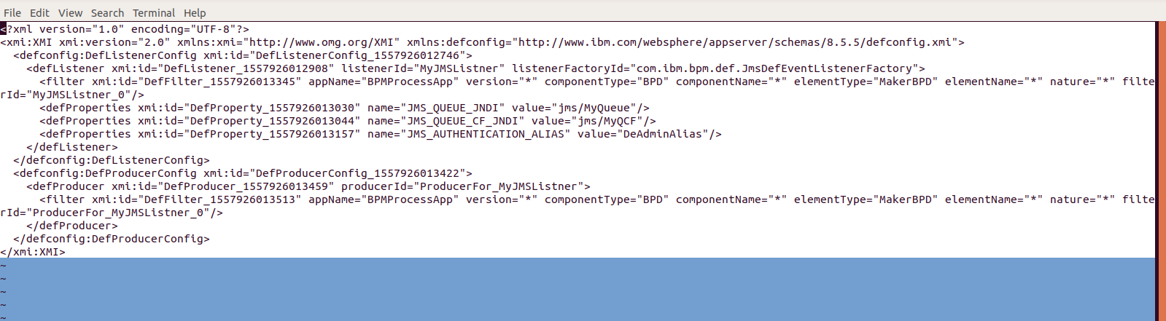
Next, you need to examine the messages in the destination queue craeted inside the BUS.
Login to WAS admin Console and go to the path as follows:
- Click Service integration > Buses and click the Business Automation Workflow deployment environment bus.
- Click Destinations and find your destination queue.
- Click Queue points.
- Click the Runtime tab. Under General Properties, you can set the Current message depth.
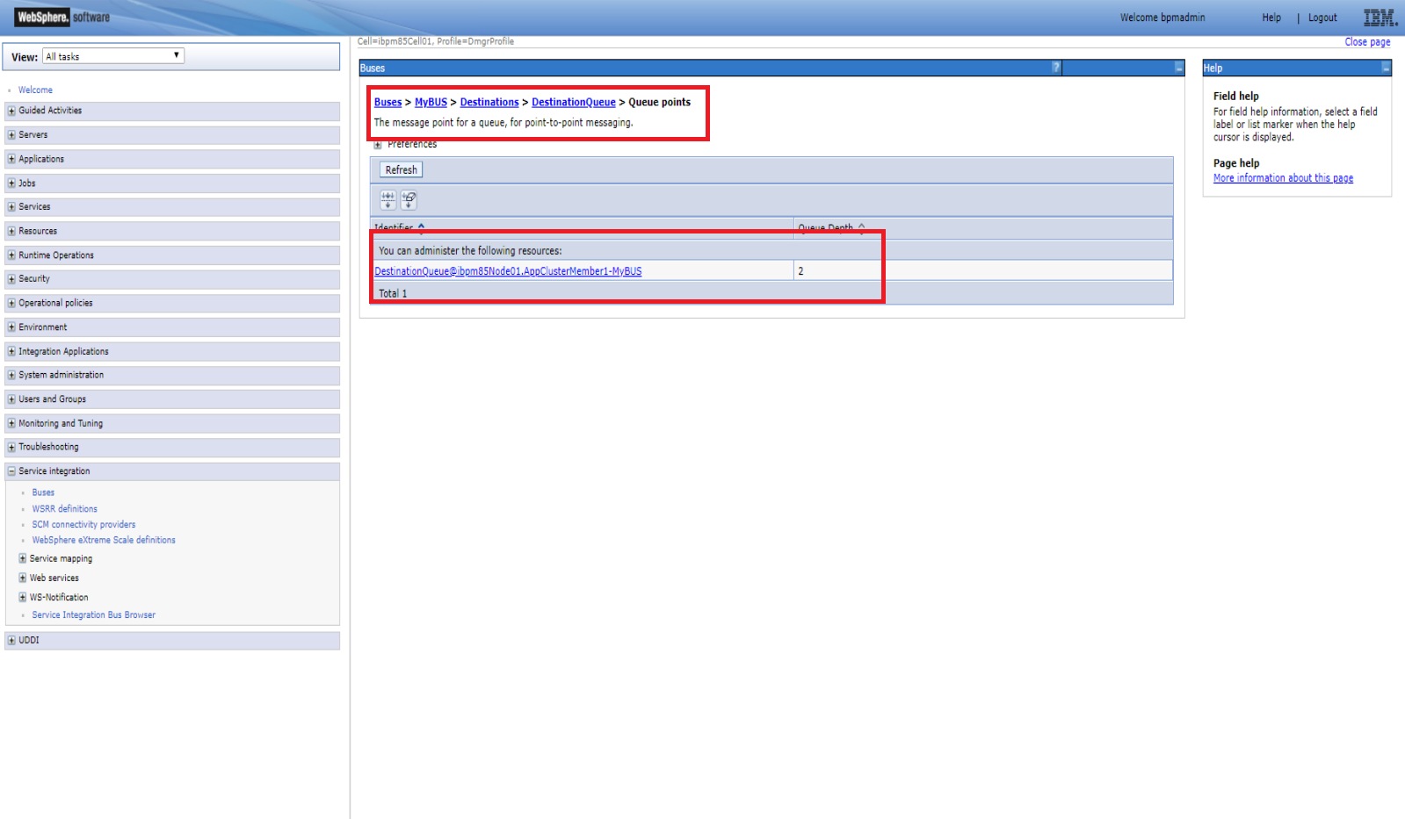
- Under Additional Properties, click Messages to see the messages.

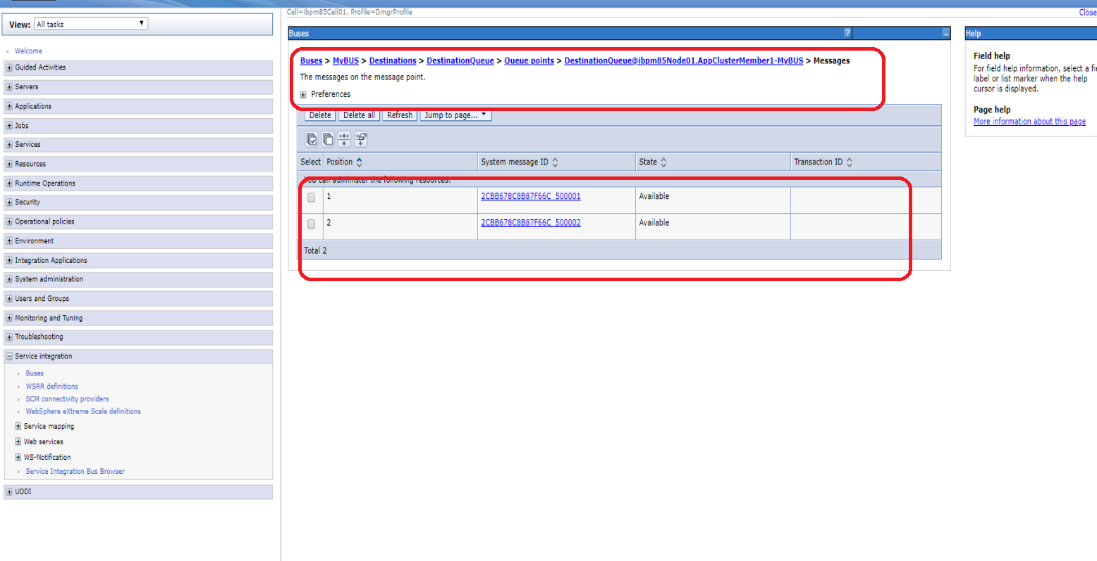

For more details follow the link
https://www.ibm.com/support/knowledgecenter/en/SS8JB4/com.ibm.wbpm.admin.doc/topics/capturingevents.html

